Summary Tissue Engineering

## College 1 – “An introduction to Tissue Engineering” – 22nd of November 2012

There are many definitions of tissue engineering:  
(the central subject is functionality)

* “Tissue Engineering is a field that supplies the principles of engineering and the the life sciendes towards the development of biological substitutes that restore, maintain or improve tissue function”  
  *Pittsburgh Tissue Engineering Initiative*🡪The tissue we want to repair are almost always in a mechanical system with a function.
* “Persuading the body to heal itself by the delivery of molecular signals, new cells and and supporting structures”  
  *Professor David Williams*🡪Extra cellular matrix structure is made by cells, that gives it function.
* It is an imitation of morphogenesis and development.  
  **Morphogenesis** literally means the "beginning of the shape". It is the [biological process](http://en.wikipedia.org/wiki/Biological_process) that causes an [organism](http://en.wikipedia.org/wiki/Organism) to develop its shape.
* “Developmental cascade of pattern formation , establishment of body plan and architecture of mirror-image bilateral symmetry of many structures and asymmetry of some, culminating in the adult form”  
  *Reddy H. Tissue Engineering (embryologist)*🡪 If we can replicate in utero, we can make the right environment for for example woundhealing.
* Morphogens are inductive signals that initiate and govern tissue morphogenesis, based on tissue interactions that are dynamic and reciprocol.
* Stem cells are primordial progenitors with enormous potential.  
  🡪 Regenerative medicin will mean the implementation of stem cells.
* Biomaterial scaffolds to mimic ECM.  
  🡪On basis of human ECM, so it will not be toxic. When it will break down the waist material will not be toxic either. Ideal would be not a fast degrading scaffold, but one which takes some time to degrade. This means the waist material is not in big amounts present.
* “Cell Engineering is a field that supplies the principles of engineering to living processes within cells”  
  🡪 On basis of the biochemistry of cells.
* “Cells are the enablers of change”  
  *R. Nerem*  
  🡪 Biology is producing technology.
* “Biology will define scientific progress in the 21st Century”  
  *Business Week*  
  🡪 When producing a new part the surgeons should be involved in an early stage. Especially older surgeons are not wanting to change.

### Biomaterial industry is segmented into:

* Artifical organs
* Biosensors  
  Measure the biomarkers in tissue to know the health of the tissue.
* Biotechnology
* Commodity and disposables
* Drug delivery/ hybrid artificial organs  
  🡪 Biodegradable coatings  
  The materials used in the industry are metals, polymers and ceramics.  
  There are 6 classes of biometals, the corrosion properties of these metals are very important.
* Maxiliofacial / dental / ENT/ cranial  
  Dental product are often used for experimenting, since you can clearly see what happens.  
  Relating to or involving the maxilla and the face.
* Opthalmology  
  **Ophthalmology** is the branch of [medicine](http://en.wikipedia.org/wiki/Medicine) that deals with the anatomy, physiology and diseases of the [eye](http://en.wikipedia.org/wiki/Human_eye).
* Orthopeadics
* Packaging
* Tissue engineering
* Wound healing

### Basis underlying conditions that warrant a treatment regime:

1. Gross congenital defects with functional consequences e.g. heart defect, hydrocephalus (enormous pressure in the head, solution: catheter)  
   🡪 People who are born with things which do not function properly.
2. Developmental defects with functional consequences e.g. scoliosis.  
   🡪 solved putting a force on the spine to straighten it.  
   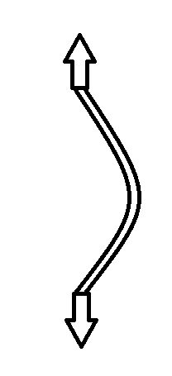
3. Organic disease leading to body malfunctions e.g. osteoarthritis, arteriosclerosis.
4. Tumours necessitating tissue resection and reconstruction  
   🡪 The tumour is cut out and replace with other tissue.
5. Tissue atrophy e.g. alveor ridge resorption.
6. Trauma requiring replacement of tendon e.g. tendon or temporary support e.g. fracture fixation.  
   Fracture is associated with mechanical loading. While the bone is fracture the pin will bear the mechanical load.   
   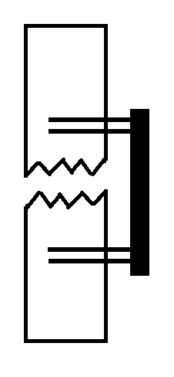
7. Psychological conditions e.g. rejection of dentures
8. The desire for an abnormal situation e.g. fertility control

### Functions of major prostheses:

1. Load transmission e.g. fracture fixation devices, tendon/ ligament replacements, dental implants.
2. As a bearing surface e.g. total joint replacement, chondral . osteochondral defects.  
   🡪 For example with cartilage breakdown.  
   The solution will need to be able to move between the parts.
3. For the control of fluid flow
   1. To simulated normal physiological conditions, such as heart and vascular prostheses, urethral replacements.
   2. In the abnormal saturation, such as ventricular catheter valves used for the control of cerebrospinal fluid.
4. For passive space filling e.g. cosmetic surgery, rhinoplasty
5. For space filling for functional reasons e.g. cranial plates to protect the brain from further damage.
6. The generation and application of external stimuli e.g. cardiac pacemakers, specific neuromuscular electrodes.  
   🡪 Works with the pacemaker  
   When the spine is injured it can be used to stimulate the muscles electrodes (ethics).
7. Transmission of light – intra ocular prostheses
8. Transmission of sound – ossicular replacement materials

### Biomaterials:

**Philosophy**

* Non-toxic
* Traditionally, bioinert/ biostable materials were employed with a minimal host tissue reaction. This will lead to encapsulation of implant  
  🡪 Corrosion: The local damage is what you think of a first, but the toxic material will go into the lymph-system where they will eventually cause a inflammation.
* Development of bioactive and biodegradable materials were employed with controlled reactions.  
  🡪 Designed to interact with the body  
  the implant will just react at the site and then start to break down.
* Some biomaterials form chemical bonds with tissues stabilising the implant e.g. Hydroxyapatite or Tricalcium phosphate coating.  
  🡪 These will chemically bond with local bone, but is very brittle when the whole implant is made of it.
* Some biomaterial resorption is acceptable in the body when implant is no longer required e.g. PLLA sutures, drug delivery capsules.  
  🡪 Often made of lactate, when the degradation rate is too fast the pH will drop.

**Design**

The biomaterial will react, there no such thing as an inert biomaterial.

The reaction will happen at the surface from the implant, so the surface material is important.  
(Corrosion will give a surface reaction)

Biocompatibility:  
1. Response of biomaterial  
2. Response of host environment

### Material selection based on several consideration:

* There is biocompatibility between the material and its environment.
* There is compatibility between the mechanical and physical properties of the two systems.
* There are fabrication methods available. This must take into account material cost, storage and sterilization possibility.  
  🡪 Sterilization an change the product.
* There is reproducibility & quality control of materials  
  🡪 For the industry this means when something goes wrong there will be legal issues.

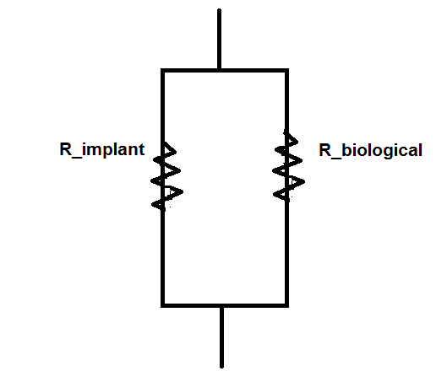  
🡪 When R­implant>>Rbiological the cell will degrade and die eventually. Since polymers have a more similar Young’s modulus to the body than metals, polymers will be a better implant.

### Implant structure

1. It must be surgically convenient to use  
   🡪 e.g. The top/bottom of an implant, what are the issues of surgeons? Involve them with the development!
2. It may be capable of fixation
3. It should minimise trauma in surrounding tissues  
   🡪 It should not destroys not destroy healthy tissue while implanting.
4. It should be radio graphically visible or MRI
5. It should meet specific functional requirements e.g. non-turbulent blood flow through valves.
6. Ideally the implant would have a lifetime comparable to that of the patient.

Performance of the implant will depend of material design, implant shape, biomechanical factors, tissue respons/adaptation, the healthy/condition of the patient, the effectiveness of clinical procedure.

### Implant production

The time it takes from concept to patient is over 10 years. While developing there is no money coming in, you need a business. It is important that there is enough market for the product (message: you create a device and you match it to the unmet need). Investors are profit driven!  
Ethical issues are important to think about.

### Host tissue can respond in different ways:

1. Accute (inflammation and remodelling processes)
2. Chronic response (undesirable)
3. Chronic response – adaption (desirable)  
   🡪 after 1 year the tissue can either fail or improve the current condition.

* Mechanical response  
  🡪 the mechanical response will change all the time.
* Host response
  + In vitro testing  
    (simulated body fluids, cell cultures)
  + In vivo testing  
    (Animal testing, clinical trials)  
    🡪 animal testing (is the animal big enough?)

### Biomaterials implants:

* Total joint replacement  
  🡪 usually older patients since it has a life time of max. 15 years. The functionality is limited, you are not able to jog.
* Large blood vessel  
  🡪 Made with Teflon and keflon, blood vessels of more than 6 mm diameter.
* Small blood vessel  
  🡪 Not yet able to make good replicas, since there is too much interaction (surface-volume ratio is bigger).
* To stimulate growth 🡪 growth factor.

### Tissue engineering:

**Possible with the following disciplines:**

* Discovery of biological revolution
* Cell technology
* Construct technology
* Integration into living systems
* Clinical application

**The development of tissue engineering:**

In 2000 tissue engineering was a very sexy industry. It was a hype, everyone was optimistic.

In 2004 the hype had dropped, the companies had overstretched themselves.   
The smaller companies had build up a bigger companies, which had fell into smaller companies.   
The bigger pharmaceutical companies watched what happened, but were not willing to save them (the biological components are too unpredictable).   
Therefore after 2004 companies much more realistic in terms of their expectations

In 2008 another peak after that it became a more stable industry.

1. A question on the exam:  
   What were the problems leading to it? How will this progress?

### Companies tissue engineering

**Skin** – HUFFs (Human Foresin Fibroblasts):  
🡪 Younger cells will give more active fibroblasts.  
🡪 One company: patient cells are intergrated in the designed tissue.

**Cartilage:**  
🡪 autologous chondrocytes  
🡪 banked allogenid chondrocytes  
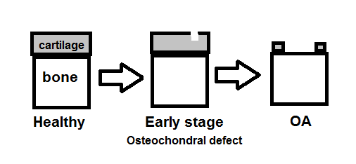

Patch can be done over the defect and an injection with stem cells.

**Goals of tissue engineering:**

1. Fabricating living tissue equivalents
2. Developing materials which promote remodelling
3. Re-surfacing non-biological materials
4. Growing 3D-structures
5. Developing vehicles for the introduction of genetically manipulated cells  
   🡪 scaffold techniques

**Pro’s of tissue engineering:**

* Avoids surgery
* Allows replacement of only those cells with the required function
* Permits manipulation of cells before infusion

**Cons of tissue engineering:**

* Failure of infused cells to maintain their function in the recipient  
  (not changing the phenotype, although you push them into something)
* Immunological reaction  
  🡪 Problem with allergenetic cells can be rejected.

**Tissue inducing substances**

* Purification of appropriate signal molecules such as growth factors  
  🡪 allow host cells to produce their own tissue
* Large-scale production of signal molecules
* Development of methods to target molecules

**Cells seeded on/in scaffolds**

* Open or closed system
* Natural materials
* Immunological acceptance with the use of:
  + Immunosuppressive drugs for suppressing the immune system
  + Autologous cells

Should we use cells from the patient or a cell bank?

## College 1 – 29th of November 2012

**Design Phyilosophy**

Different components  
Cells (optional) + ECM (may) + Scaffold (usually) + Signals (e.g. biomedical, biomechanical, bio-electrical) = Tissue Engineered Biological Substitute  
🡪 Construct = physiologically build

**Cells**

* Cells have finite lifespan - then expire
* Multi-step lineage pathways generate newly differentiated cells
* Newly differentiated cells replace expired cells   
  🡪 The cell dies, before they die they will divide
* Fabricate ECM and neo-tissue   
  🡪 new origin

**Intelligent Scaffolds (Multifactorial Delivery Vehicles)**

* Hold or attract cells
* Influence cell development
* Reserve space for regeneration   
  🡪 Biodegradable scaffold will give after some time more space for new cells.
* Inhibit inflammatory events
* Breakdown into active factors (e.g. stimulate cell growth)
* Encapsulate morphogens, cytokines and MMPs   
  🡪 MMPs break down proteins
* Facilitate integration
* Contribute to final events

**Manufacturing Processes**

* Tested cells from working cell banks
* Automatic injection into tissue bioreactors
* Computerised system to monitor growth conditions including pH, CO2 and glucose utilisation (sensors)
* Tissues are frozen (for transport)
* Quality control for matrix properties and cell viability (tests)
* Processed in bioreactors until clinical use

1. In the U.S.A. tissue engineering started in the biochemical departments. In the U.K. the biochemical departments are busy in the oil industry.

**Cellular Signal Transduction**On Micro-level:

* Chemical pathway (ionflows)
* Mechanical ques

*What enable the cells to respond?  
🡪 The conditions they are in.*

**Artificial Tissue Development of Cells**

* Availability
* Source
* Protein expression level (screen the cells)
* Response to physiological stimuli   
  🡪 Mechanical history  
  e.g. Isolated cells in cartilage which is frequently loaded, will respond differently than cells in cartilage which is not frequently loaded.
* Long term maintenance of
* function

**Of Biomaterials**

* Immunoprotection
* Biocompatibility
* Mechanical stability  
  🡪 At least initially, to match the environment.

Often collagen scaffolds are used in tissue engineering:

* Making collagen is difficult
* How do you know if new collagen is made by the cells?  
  🡪 Use a different type of collagen in the produced tissue than the cells will make. You can use Western Blotting to know which is which.  
  🡪 Usually radio-isotopes are used to know is there are any new cells.

**TE Medical Products Require Innovative Regulatory Strategies**

* Safety characterisation   
  – novel biomaterials
* Biological complexity   
  – biological components lead to product variability and testing complexity   
  🡪 How to establish such a test protocol?
* FDA Multi-centre review
* combination products require Inter-centre review
* Guidance and Standards
* need for cell/tissue standardised characterisation methods, reference materials and guidance   
  🡪 Tissue is a dynamic material

**LIFE Intitiative - Objectives**

*Objectives - to produce an unlimited supply of human vital organs (heart, kidney ,liver) for transplantation.*   
Because there is a large unmet medical need. A new organ is cheaper for the society than the treatment in the last six months of their life. There are ethical issues associated with limited resources (how do you determine who gets the organ?).  
The fatigue is an important issue for the engineered tissue.

**Exam: Write the milestones within a 10 year program of an organ and what are the expected spin-offs of the research?**

**Example of the heart - Milestones**

* Functional heart available for pre-clinical testing - year 10
* Thrombogenicity control - year 9   
  🡪 minimize the risk for trombose
* Components human testing - year 8
* Immune/Inflammatory control - year 7
* Components small animal testing - year 6
* Prototype cell and scaffold strategies - year 5
* Flexible scaffolds with required stiffness/strength throughout degradation period - year 3
* Human cardiomyocytes in large numbers from various sources - year 2

**Examples of the heart - Selected Spin-Offs**

* Animal models for human diseases - year 10
* Endothelial seeding of vascular grafts
* Vascular networks (capillary beds) and conduits
* Paediatric cardiac valves
* Cardiac patches for repair of damaged tissues - year 5
* *In vitro* model for conduction based diseases
* Degradable materials for other TE applications
* Cardiac cells for injection and *in situ* repair
* *In vivo* culture of cardiac myocytes - diagnostic and drug testing

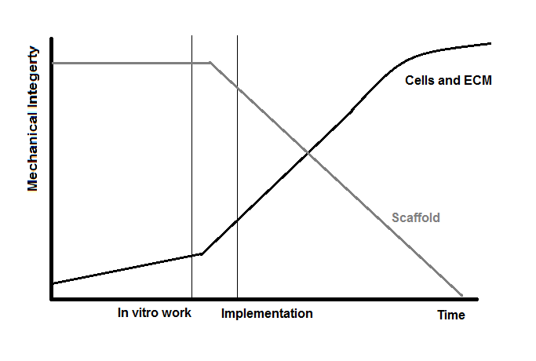

You have to produce some ECM in the scaffold before the implementation otherwise it cannot bear any load.

You want the scaffold to evoke cells to come to the scaffold and start producing ECM (e.g. hyaluronan does that).

# College 2 – “Cells” – 29th of November

**Cell Structure (important sites)**

1. Plasma membrane
   1. Ion channels  
      🡪 Ion will determine how a cell performs.
   2. Transmembrane proteins
   3. Receptor molecules
   4. Microvilli

* What happens outside the cell can influence the nucleus.

1. Mitochondrion  
   Cytoplasm (the cytoskeleton, ER and Golgi compelex is located in here)
2. –
3. Cytoskeleton
   1. Microtubuli
   2. Intermediate filaments
   3. Actin filaments

🡪Link the nucleus to the cell membrane

1. Nucleus
   1. Nuclear envelope and nuclear pores
   2. Chromatin (DNA and histones)
2. Endoplasmic Reticulum (smooth/rough)  
   🡪 Protein synthesis
3. Golgi complex
   1. Secretory vesicles
   2. Lysosomes

* Often the protein production is studied with molecular biology but also the analysis of protein in ECM is important.
* Proteins etc. are transported in and out the cell with exocytose and endocytose.

**Sorts of cells:**

* Fibroblast
* Flattened/elongated morphology

–Divides extensively

–Possess cell processes

–Synthesize non-rigid matrix

* Collagen
* Versican
* Small PGs, for example, decorin

–Capable of differentiating into several mature cell types

* Chondrocyte
  + Rounded morphology( may be discoid in surface zone of cartilage)   
    –Mature articular chondrocytes do not divide

–Cell processes - cilia?  
–Synthesise cartilage matrix

* + Collagen **II**, VI, IX, XI
  + Aggrecan
  + Hyaluronan
  + Alkaline phosphatase (in calcified zone)   
    –Capable of undergoing hypertrophy during calcification process   
    –Capable of dedifferentiating to fibroblast morphology in culture conditions
  + Avascular tissue  
    🡪 so cannot use oxygen for energy, it uses glucose instead
  + In monolayer chondrocyte will become a fibroblast, you can tell from the type of collagen that is produced by the cell.
* Osteoblast
  + Cuboid morphology
  + Capable of dividing
  + Synthesise bone matrix   
    - Collagen I   
    - Osteonectin   
    - Osteocalcin   
    - Hydroxyapatite   
    - PG   
    - Alkaline phosphatase   
    🡪 these are all bonemarkers
  + Differentiate into osteocytes, which are embedded in matrix (mechanical load sensor).

**Extracellar Signalling Molecules**

* Hormones - Insulin, human growth factor
* Growth factors - FGF, PDGF   
  🡪 Different growth factors have a role in different cells.  
  🡪 Specific growth factors are only needed to stimulate certain processes instead of the whole coctail
* Cytokines - Interleukin -1b
* Neurotransmitters
* Prostaglandins - PGE1, PGE 2/3
* All are relatively small molecules <50kD
* Hydrophilic - bind to cell surface receptors e.g. FGF   
  Hydrophobic - diffuse through the plasma membrane and bind to receptors inside the target cell e.g. steroids
* Cellular fate processes that underlie the dynamic states of tissue function   
  –Cell division - an increase in cell number   
  –Cell differentiation - changes in gene expression and the acquisition of a particular function   
  –Cell migration - motion of a cell into a specific niche or location   
  –Cell apoptosis - programmed death of cell   
  –Cell adhesion - physical binding of cell to its immediate environment i.e. neighbouring cell, ECM or artificial surface
* Effects   
  –On the same cell - autocrine   
  –Local - paracrine, synaptic   
  –Remote - endocrine

**Cell therapy**

* First there was transfusion of cells. The first cells to be donated were blood, after that whole organs were transplanted. The first kidney to be transfused successful was in 1962, than more organs and cells succeeded.
* How many cells do you need for a working organ?  
  The body has 1014 cells, an organ 109-1011
* The fundamental limitations to the production of primary cells number of cell divisions in culture 30-50 doublings depending on age of cell, in theory, >1010 cells not all cells grow easily in culture e.g. liver and b-islet cells.
* How rapidly do primary cells grow in culture ?   
  Dermal foreskin fibroblasts (HUFFs) exhibit doubling times of 15 h, adult chondrocytes exhibit doubling times of 24-48 h.  
  🡪 Depends on the activity of the cell.
* How are these cells currently produced ?   
  Fairly primitive i.e bags, T flasks and bioreactors.

**Tissue Dynamics**

Tissues are composed of many cell types of various developmental origins . The dynamic behaviour of cells and their interactions determine overall tissue formation, state and function. The three dynamic states of tissue are:

1. Tissue histogenesis - normal steady-state function of tissue   
   –cell production (skin, bone marrow), mass transfer (lungs, kidney),

–biochemical “refineries” (liver)

1. Tissue formation - the field of developmental biology
2. Tissue repair - biopsied tissue displays a healing type response in culture

* These thing change all the time.
* The time to make enough cells for one organ varies a lot.

**Communication**

Cells in tissues communicate with each other in 3 principal ways:

1. They secrete soluble signals, known as cytokines and chemokines e.g. growth factors
2. They make direct cell-cell contact
3. They make proteins that alter the chemical microenvironment (ECM) On the cell surface there are adhesion and ECM receptor molecules

Each communication differ in terms of

–characteristic time and length scales

–their specificity

  
(two cell interacting with each other and the ECM)

## Stem cells

Definition - Undifferentiated cells with the potential to differentiate and generate a large number of mature cells of one or more lineages.

Features:

* An unlimited replication potential (for self-renewal)
* Morphologically indistinct - have a high nucleus/cytoplasmic ratio
* Commitment to differentiate in culture, slow at first, then at a rapid rate (maximum doubling time 12-14 h.) (also slow; all sorts of tissues)
* Stem cells systems in rapidly proliferating tissues e.g. skin, bone marrow but also in organs with slow rates e.g. liver, b-islet cells
* Stem cell commitment initiates organ function, repair and genesis

Sources:

* Some adult tissues
  + Isolation and growth of stem cells from adult tissues
  + Stem cells found in certain tissue types e.g. bone marrow and peripheral blood, hair, skin, adipose tissues etc.
  + Resulting stem cell lines thought to be capable of differentiating into limited range of tissue - recent research suggests otherwise   
    🡪 now: push the differentiated cells push them back into an undifferentiated state. Differentiation pathways are directed by specific growth factors (the interactions between the cell and the environment are quite complicated to interpret).
  + Resulting tissue may be genetically compatible or not (donated)
  + Successful transplantation of some stem cells e.g. from bone marrow, has been possible for some years
  + *No specific legal restrictions*
  + *General legal provisions on removal and use of human tissue apply*

🡪 Potential from an adult cell is less than from an embryonic cell.

* Some foetal tissues
  + Cells from aborted foetuses or umbilical cord blood of newborn babies
  + Tissue sources are readily available and current use is restricted only by the need for consent from the mother
  + Tissues rich in stem cells e.g. liver can be extracted and cells successfully grown and concentrated in the laboratory
  + Resulting stem cell lines capable of differentiating but may only be capable of forming some types of tissues but not others   
    🡪 totipotent 🡪 pluripotent 🡪 multipotent.
  + Resulting tissue not genetically compatible with the subject being treated unless cord blood stored at birth for future use
  + *No specific legal restrictions on use of foetal tissue or cord blood*
  + *Some regulations which require Research Ethics Committee approval*
* Ethical/religious issues
* Great potentials!
* Umbilical cord blood
* Early embryos   
  –created by *in vitro* fertilisation (IVF)
* Reprogrammed adult cells (theoretical)

–using cell nuclear replacement techniques

**Summary Embryonic Stem Cells**

* ES cells are developmentally transient in the embryo since they only can be generated from 5-7 cay old blastcyst.
* Biological function lies in development to construct the whole body.
* They are capable of undergoing an unlimited number of symmetric divisions.
* ES cells are pluripotent: they can differentiate in every germ layer, tissue or cell.
* ES cells are capable of colonizing the germ line and giving rise to eggs or sperms.
* Clonogenic properties: a single cell can give rise to a colony of genetically identical cells, or clones, which have the same properties.
* ES cells express specific markers.
* Grown on feeder layers, thus a risk of viral infection exists: also clean separation of animal cells and human technically not solved: however, new techniques exist which allow growth of ES cells without feeder layer.
* Unlimited proliferation potential after transplantation: risky, since it could result in cancerous growth.
* People claim that ES cells are a cell culture artifact since there is no natural role for them in regeneration.
* Are the biological progenitors of adult stem cells but relationship between ES cells and adult stem cells is not clear.
* ES cells are ethically controversial.
* There is a reasonable hope that ES cells could be used in clinical applications.

## College 3 – “Skin” – 13th of December 2012

**Anatomy of skin**:  
Skin has two layers:

1. The epidermis (the outer, thinner layer):
   1. Cell types
      1. Keratinocytes (about 90% of total cells)  
         (Corneocytes 🡪 after keratinocytes go to the outer layers, located in strata corneum)
      2. Melanocytes  
         🡪 Produce melanin, which colours cells (pigment)
      3. Langerhan cell – immune response
      4. Merkel cells – touch sensitive
   2. Structural features
      1. Five layers (strata)  
         Strata -basale, -spinosum, -granulosum, -lucidum and –corneum  
         🡪 from inside to outside the body
      2. Avascular and alymphatic
      3. No nerve endings
   3. Epithelial tissue
      1. Keratin
      2. Melanin
      3. Lipids

* The thickness of the epidermis is normally 200μm, but at the hands and feet 2-3mm.  
  Best is to measure the skin thickness with ultra sound.
* Interacts with the outer-world.

1. Epidermal-Dermal junction  
   🡪 Molecule transport is possible over the junction, as is information transport.  
   🡪 The junction is wavy.
2. The dermis (the inner, thicker layer):
   1. Cell types
      1. Fibroblasts / myofibroblasts
      2. Microvascular endothelium  
         🡪 to produces blood vessels.
   2. Structural features
      1. Blood and lymph vessels
      2. Hair follicles, serbaceous glands and sweat glands
      3. Nerve
      4. Papillary dermis and Reticulum dermis  
         Papillary dermis is positioned above the reticulum dermis. The change between the two dermises is graduate.
   3. Extracellular matrix
      1. Extracellular water
      2. Collagen
      3. Elastin
      4. Proteoglycans  
         Glycosaminoglycans (GAGs),  
         🡪 hyaluronan, dermatin sulphate, chondroitin-6-sulphate, heparin sulphate  
         🡪 A lot of water is in the tissue because of the interaction between the sulphate-groups and the hydrogen atoms of water.

**Function of Skin**

* Regulation of body temperature (homeostasis)
* Sweating
* Changes in flow of skin blood flow
* Burning wounds will give problems with the cooling down of the body.   
  (Most burning wounds with people younger 10 years old or elderly people.)
* Protection of underlying tissues/organs
* Physical barrier against abrasion, bacterial invasion (chemical), dehydration and UV radiation
* Hairs and nails also offer protection
* Total area of skin is 2 m2.
* Sensation
* Detects stimuli related to temperature, touch, pressure and pain
* Excretion
* Small amounts of water, salts and organic compounds are excreted via sweat glands
* Immunity
* Langerhan cells fend off foreign invaders of the body  
  🡪 Langerhan cells will set up antibodies.
* Synthesis of Vitamin D
* Initiated by UV exposure – aids in the absorption of Ca &P from the GIT to the blood

Mechanical Properties of Skin

* Testing modalities

Tension, Biaxial, Torsion, Shear and Compression Suction testing

* In vivo versus in vitro testing  
  🡪 In natural state the skin is under pretension (due to elastin and collagen (critical orientation).  
   While testing the skin should be stretched and kept moist.
* Directional aspects – Concept of Langer lines  
  🡪 In natural state skin is anisotropic, this is because the collagen fibers have a preferred direction.  
  🡪 The surgeon will cut the patient so that the wound will rather close than open (Langer Lines).
* Changes with age – increase in collagen cross- linking  
  🡪 The skin will stiffen with age due to this, also because the elastin production decreases.

**Specific Wound Types**

* Acute  
  – Elective wounds   
   🡪 patient has chosen for it (e.g. surgery)  
  – Surgical wounds - generally repair  
  – Burns - due to their potential mortality -TE an obvious option but market is not predictable ?  
   🡪 Major burns >20% BSA (body surface area)  
   Severe burns >60% BSA  
   🡪 Treatment options: surgical skin transplantations involving split skin graft and mesh   
   autografting.  
   - Often results in scar formation and wound contraction – hence poor cosmesis and limited   
   joint mobility (functional effect).  
   🡪 Burn wounds can extend through the epidermis into the dermis. Therefore the ideal TE   
   product would act as a total skin equivalent (comprising both epidermis and dermis). If we   
   want to develop engineered skin; fibroblasts and keratinocytes should inserted.
* Chronic  
  – Venous leg ulcers and arterial ulcers  
   🡪 Venous ulcers are caused by venous return (not pressure!).   
   🡪 Arterial ulcers are due to a lack of supply.  
  – Diabetic ulcers  
   🡪 Diabetic people don’t feel pain in e.g. feet, that is why they get these ulcers.  
  – Pressure ulcers (doorligplek)  
   🡪 Their incidence increase with age and represent the future goal of TE technology  
   🡪 10% of the people in a hospital get a pressure ulcer. In 2009 in the USA a law has been   
   introduced that obliges the hospital to give a compensation if the patient gets a pressure   
   ulcer. So it is getting more important in the programs.  
   🡪 It can go up to the bone and the wounds are smelly.  
   🡪 Patients can die from it (Actor Superman).

**Potential Approaches to TE**

1. Epidermal replacements - consisting of keratinocytes grown either alone, on the surface of a tissue culture flask) or in close association with a carrier vehicle such as a polymeric film or bioresorbable matrix
2. Dermal replacements - consisting of a structure able to support infiltration, adherence, proliferation and neomatrix production by fibroblasts and possible endothelial cells.

## Skin substitutes - a combination of 1 and 2.

**Formation of Support Structures**

* support cell ingrowth
* provide a suitable substrate for adherence
* facilitate cell proliferation and production of ECM
* resorb from wound site in a controlled manner  
  🡪 or breakdown with time
* minimal toxicity
* low immunogenecity
* mechanical properties similar to uninjured tissues
* Candidate materials - collagen (bovine or porcine sources) fibrin, fibronectin, chitin/chitosin, chondritin-6-SO4, basement membrane proteins, hyaluronan, PLA, PGA  
  🡪 a lot of proteoglycans
* Natural and synthetic tissues are used by the companies.

**Historical Perspective**

* *Eugene Bell* found that fibroblasts could infiltrate a collagen gel and turn it into a fibrous living matrix. (also by diffusion)
* *Yannas and Burke* developed a dermal component of bovine dermal type I collagen crosslinked with C-6-S (sulphate) on a silicone backing sheet.
* *Handsborough* noted that when allogenic fibroblasts were seeded into a PLA/PGA matrix, many components of ECM are synthesised including collagen (types I,III,IV), elastin, fibronectin and decorin.

**Commercial Perspective**

* The Organogenesis story
* A skin equivalent construct, Apligraf TM
* The Advanced Tissue Sciences story
* Transcyte TM and Dermagraft TM
* See the articles.
* One offered their product too cheap 🡪 not enough profit  
  One too expensive  
  Both their first attempt did not exceed to make profit.

### Professors Harry Navsaria and Irene Leigh (Queen Mary)

🡪 Skin Tissue Engineering Myth or Reality?  
🡪 Can we produce quick epidermal damage?

**Improvements in Keratinocyte Technology**

* Culture conditions
* Serum free media  
  🡪 Culture media is critical (expensive…).
* Exclusion of xenogenic material
* Delivery systems (pre-confluent)
  + membranes ( hyaluronan, Collagen, PLA etc)
  + microcarriers / beads  
    🡪 Where cells grow on outside.
  + Sprays  
    🡪 force should not kill the cells, controlled spray technic is needed.

Convential keratinocyte grafting: wait untill 100% confluence is totally covered.  
Pre-confluent keratinocyte grafting: not directly grown on the glass but on a film, wait untill 70% full. So it is a short-time-process.

**How do you evaluate wound product?**

1. Take on the back of a pig the skin away (pigs of the same breath and age).
2. Put the engineered skinmodel (autologous cells) back in the hole.
3. Look at how the hole will heal.

Results after 6 weeks:

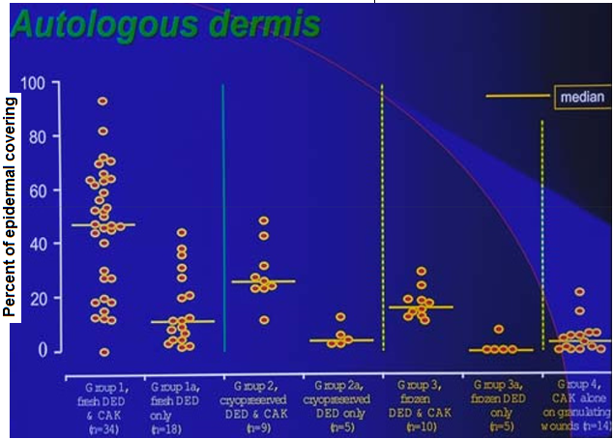  
7 groups: 3 pairs and 1 single.  
Conclusions: 1. Medium of group 1 is the highest 🡪 Keratinocytes and dermis have an interaction.

2. It is big range.

Study with allogeneic dermis: the effec of using allogeneic dermis is less significant.

* Fromation of neo-dermis and vasculatrisation is complete only takes places under areas of epthelial cover.
* Normal innervation is achieved only in the presence of epidermis.
* Optimal attachement, proliferation and differentiation is only oissible in the presence of dermis.

**Hyaluronan (Hyaluronic acid) – Fiddia (Italian company)**

* Endogenous part of extracellular matrix
* High levels in foetal tissue  
  🡪 we are trying to imitate what happens in the embryo.
* Chemotactic to mesenchymal cells
* Increases collagen deposition in vivo
* Pro-angiogenic
* Enhances Cultured Epithelial Autograft (CEA) take
* Tested on the back of pigs. The results showed that the product enhances the wound healing to be more quickly. In the section of the wound bed could be seen that there were more fibers and epidermal-dermal junction in the HA-treated wound than in the control-group after 6 weeks.

Do allogeneic fibroblasts survive transplantation?  
After 7 days *in vivo*, less than 0.01% of cell population derived from allogenic fibroblasts. Is it usefull? We do not know, but there is evidence that they are usefull in the initial kick off.

**Post-Grafting Complications**

* Globally 6 million patients require extensive grafting
* Contraction occurs with conventional skin grafts
* Estimated 30% of all conventional skin grafts (thin split thickness skin grafts) for extensive thickness burns injuries or traumatic skin loss
* Prevention by short-term immobilisation, splinting of grafts and wearing of pressure garments (worn for > 1 year)  
  🡪 Compression to try to minimize the contraction.
* May be preconditioning will help.

**Scars:**

* Scar Prevention
  + Potential problem in tissue engineering
  + Interfacial problem - integration of graft with minimal scarring at the edges e.g. wound repaired with graft pieces - resembles “an array of postage stamps” with excess scarring at the interfaces.
    - You want to integrate the TE product with the healthy tissue for interaction.
* Wound healing  
  Scarring is an overproduction of wound tissue, too much remodeling on the edge of the tissue.
  + Chronic wounds - fail to heal
  + Hypertrophic scarring - important in severe burns
  + Keloids - important in minor injuries where scar tissue outgrows the boundary of the injury. Very common in Afro- Caribbeans, Chinese and Japanese populations.
* Extent of Problems involving Scarring
  + Skin - surgery, bites and associated with burns
  + Eyes - chemical burns/ blunt trauma the production of connective tissues that are opaque to the cornea.  
    🡪 overproduction of collagen so it is not transparent anymore, this will lead to blindness.
  + Adhesions - gut, intestine and tendons
  + CNS (central nerve system) injury - glial scarring can prevent reconnections of nerve endings
  + Fibrotic disorders e.g. liver sclerosis
    - E.g. overproduction will stop normal movement and so the functioning.
* Traditional Therapy for Scarring (Largely palliative)
  + Nursing
  + Compressive bandaging and garments
  + Oils and massage
  + High pressure water
* TGFβ’s Role in Wound Healing  
  (Transforming Growth Factor)
  + Seconds after wounding there is a release of TGFβ’s, predominantly TGFb1 from stores in degranulated platelets. This release is independent of signals associated with gene transcription and translation.
  + TGFβ’s are chemotactic to:
    - Endothelial cells stimulating angiogenesis
    - Macrophages leading to the release of more TGFβ and other cytokines …..
    - Fibroblasts stimulating ECM synthesis and inhibiting degradation.
  + TGFβ 1 and 2 are more common in adult tissue, but in foetal tissue TGFβ 3 is most common and less TGFβ 1 and 2 are present.   
    In foetal tissue the wound always heals up, therefore to minimize scarring TGFβ3 is needed.  
    Also evidence from experimental data (he even tested it on himself)
* Current direction:
  + Genetics of Scarring
    - Use of knock-out mice( with over/under expression of cytokines/growth factors) which help to identify candidate polymorphisms/ genes which render susceptibility to keloid scarring
    - Examine DNA of families with established scarring  
      🡪 is it genetic??
    - Tissue profiling of chronic wounds, scars – mRNA technology
  + Tissue Engineering  
    The development of an anti-scarring therapy in association with TE products
* We will also have to look at post effects.

# College 4 – “Bone” – 20th of December 2012

**Chemical components of bone**

* The organic matrix is composed primarily of the protein collagen (type I) which provides ductility - 10% of adult bone mass.  
  🡪 Collagen type I is causing the ductility of the bone.  
  🡪 Collagen fibres are situated in between the ends of hydroxyapatite crystal plates and between the plates.  
  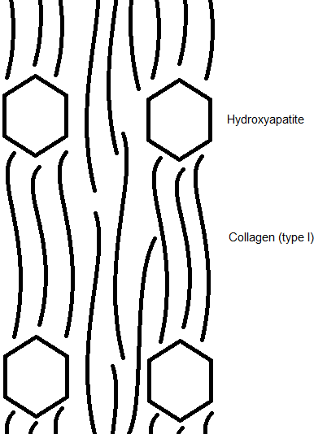
* Mineral component is composed of hydroxyapatite, which is an insoluble salt of Ca and P - about 65% of adult bone mass   
  🡪 This is why the bone is quite brittle.
* Bone also contains small amounts of magnesium, sodium, and bicarbonate
* Water comprises approximately 25% of adult bone mass
* The ratio strain to failure is in bone relatively low (0.5-3%), this means it is a hard tissue.

**Cells in the bone**

1. **Osteoblasts** are cuboidal and columnar in shape with a central nucleus found on the bone surface (occur in columns).
   1. Responsible from producing bone ECM
2. **Osteocytes** live inside the bone and have long branches, which allow contact with each other as well as the lining cells on the bone surface.
   1. they sense any mechanical strain on the bone
   2. this directs bone remodeling to accomodate mechanical strain and repair fatigue damage  
      🡪 mechanosensors
   3. they can secrete growth factors which activate the lining cells
3. **Osteoclasts** are large cells with many nuclei, which share lineage with blood cells (especially macrophages).
   1. formed from fusion of the precursors, which circulate in the blood and bone marrow. RANK receptors on the osteoclast precursors are activated by the RANK-ligand which is secreted by osteoblasts (for communication). Osteoprotegerin (OPG) is a factor which also binds RANK-ligand, thus regulating osteoclast activation.
   2. they form sealed compartments next to the bone surface and secrete acids and enzymes which degrade the bone.
   3. after resorbing bone, they undergo apoptosis, a process regulated by proteins from other cells.

* Osteoporosis (too much breakdown of bone) 🡪 common for women after the menopause. (There are also other illnesses that cause the breakdown of bone).

**Other Bone Matrix Proteins   
🡪** Need to be there for the remodelling of bone

* Fibronectin - Relatively abundant, may help regulate osteoblast differentiation
* Osteonectin - "Bone connector" may regulate mineralization
* Thrombospondin - May inhibit bone cell precursors
* Osteocalcin - Binds calcium onto phosphategroups
* Matrix-gla-protein - Inhibits mineralization
* Biglycan (a small proteoglycan)

**Hormones (small proteins or organic molecules)**

Parathyroid hormones, Calcitonin, Vitamin D, Gonaoidal Steroids, Growth Hormones, Glucocoticoids, Thyroid hormones

**Microstructure of bone**

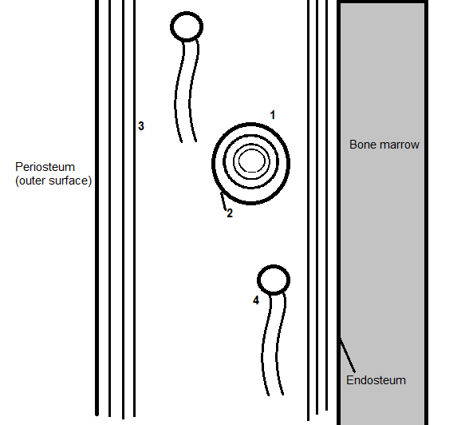

1. Osteon = centric lamella
2. Cement line (cementum)   
   🡪 often bone fractures are on this line
3. Circumferential lamella (plexiform)
4. Interstitial lamella

* Bone is highly vascular (from the outside and from the bone marrow).

## Macrostructure of bone

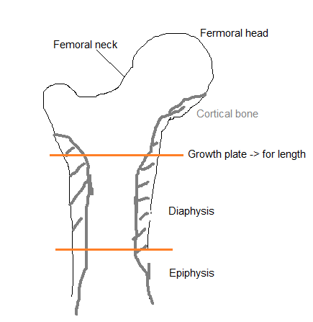  
**Growth in the growthplate**🡪 growth in length

🡪 cartilage🡪 calcified cartilage 🡪 bone

**Bone types**

* Woven bone: generally immature
* Cortical bone: compact bone
* Cancellous bone (trabecular bone)  
  🡪 The direction of the fibers are in the predominant loading direction

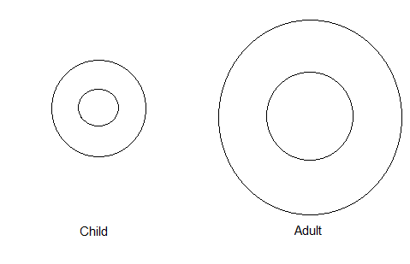

🡪 So the weight of the bone is not too much  
During growing the bone grows on the outside but is broken down at the inside.

**Function of Skeletal Bone**

* Structural support for heart, lungs and bone marrow
* Protection for brain, uterus, and other internal organs
* Attachment sites for muscles allowing movement of limbs
* Mineral reservoir for calcium and phosphorus
* Defense against acidosis   
  🡪 een ziekte waarbij de pH van je bloed te laag wordt.
* Trap for some toxic minerals such as lead

**Mechanical Properties of Bone**

* Testing modalities (Tension, compression, Bending, Torsion)
* Strain gauges to measure bone deformations both in vitro and in vivo properties   
  🡪 Strain gauges can only be used for bone and not for soft tissue. This is because the strain gauges need a rigid surface to work properly. On bone it is easy to measure the mechanical properties because of this.
* Compressive Stiffness ranges 7 -30 GPa – directional effects
* Changes with age – disease such as osteoporosis and osteopenia

**Key Features**

* Morphogens are inductive signals that initiate and govern tissue morphogenesis, based on tissue interactions that are dynamic and reciprocal (🡪 negative feedback)
* Stem cells are primordial progenitors with immense replicative potential and multi-potential capacity for differentiation into multiple lineages
* Biomaterial scaffolds to mimic ECM

**BMP’s - Historical Perspective  
🡪 Bone morphogenic growth (also in other tissues)**(recent work with knockout mice has revealed this 🡪 in these mice the ability of the gene is knocked out)

* Huggins, over 60 years ago, found certain matrices were capable of new bone formation
* Urist (orthopedic) (1965) established the key discovery, that de-mineralised lyophylized rabbitt bone can induce bone formation when implanted intra-muscularly   
  🡪 ectopic – put tissue in the wrong place  
  🡪 orthopic – put tissue in the right place
* Reddi and Sampath showed that it acts in a sequential development cascade that mimics stages of osteochondral ossification similar to that in the limb bud, important in human development (in utero 🡪 how bone develops in the embryo).
* Reddi and colleagues used dissociative extraction agents (guanidine, SDS *(sodium dodecyl sulphate)* and urea) to yield a soluble fraction (3%) and an insoluble type 1 collagen matrix. The two components need to be reconstituted for effectiveness. Bone induction markers (🡪 what induces bone growth), such as alkaline phosphatase and RA calcium, are commonly used in bioassays
* Wozney et al.(1988) were the first to clone BMP’s

**BMP’s (“floating around in ECM”)**

* Decalcified bone implants have been used to treat patients with osteomyelitis
* Bone contains a substance osteogenin (BMP-3) that initiates bone growth
* Bone induction, as in morphogenesis through cartilage, involves a multi-stage process, each regulated by BMP’s involving
  + chemotaxis
  + mitosis
  + differentiation
* BMP’s bind to extracellular matrix, such as heparin and collagen type IV. This converts a soluble morphogen into an insoluble matrix-bound morphogen that can act locally in the solid state and may protect it from proteolysis and prolong its half-life
* There are 15 BMP’s  
  🡪 It is not known why there are so many BMP’s, probably because they react in many tissues.
* If you deliver the BMP’s in the right location and in the right way, they can work.

**Pleiotropy of BMP’s**   
🡪 The production by a single gene of at least two apparently unrelated effects  
🡪 Dependent on the concentration

* Chemotaxis (optimal at fentomolar concentrations)  
  🡪 or stimulate cell movement into a chemical gradient.
* Mitosis (picomolar)
  + stimulate immature cells
  + inhibit mature cells
* Differentiation (nanomolar)
  + cartilage *in vitro*
  + bone *in vivo*🡪 However, in vivo BMP’s are not “floating around” but are bound to ECM, so their local concentrations may be higher
* Maintenance of phenotype (no differentiation)
  + cartilage
* Stimulation of matrix production

1. **BMP’s bind to the ECM (🡪 these are the key components for the development for bone)**

* ECM molecules play a key role in morphogenesis - explained by the binding of BMP’s to:
* Collagen I - bulk matrix of bone
* Collagen IV - part of invading capillaries. Vascular invasion is a pre-requisite for bone formation
* Heparan sulphate - basement membranes
* Heparin

1. **BMP Binding Proteins**

* NOGGIN   
  🡪 role in head induction in amphibian embryos
* CHORDIN
* DAN
* BMP’s have same affinity to these binding proteins in the ECM as to surface receptors on the cell membrane. (So there competition between BMP and the binding proteins).
* This controls production and limits the possibility of hypertrophic bone (negative feedback control)

**Signaling pathway for BMP’s**



* They are dimeric in form - types I and II receptors collaborate
* Type I is a protein kinase. It phosphorylates intracellular substrates called SMAD’s (1&5), which enter into the nucleus to switch on gene expression
* Once genes have been expressed, inhibitory SMAD’s within nucleus block protein kinases in the cytoplasm.
* This regulates the activity of BMP’s, thus preventing them from “going into overdrive”
* Also negative feedback in the cell (preventing from growing in the overdrive)

*Activated BMP will go into the cell than there is the phosphorylation cascade, SMAD will express the genes and after that also “anti-SMAD” will be produced.*

**Biomimetic Biomaterials - Delivery Vehicle for BMP’s**

* Collagen
  + most effective vehicle for recombinant BMP. Commercial exploitation for use in cranial and facial applications
* Hydroxyapatite
* Fibronectin
* Laminins
* Geometry critical e.g. pore size (🡪how easy is it for the cells to get in the pores?), beads/disc
* The only use of BMP’s in tissue engineering:  
  a fusion to help when there is pain in the back (vertebral column).   
  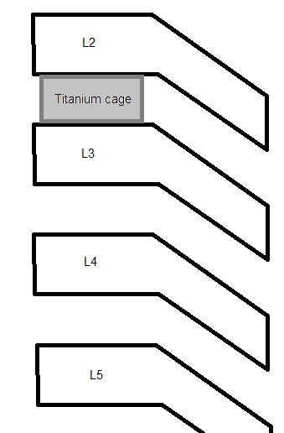  
  The titanium cage is filled with bone chips from schrum, it will take about 6 months to grow. When BMP is used that will be faster.  
  🡪 They had to prove with animals that it worked (monkeys because of the loading).  
  🡪 Problem: by stopping the movement somewhere in the vertebral column, somewhere else is more movement and loading.
* Most autografts are from the pelvis, since there is too much bone.

## Bone tissue engineering

🡪 The companies involved in the bone regeneration are usually not only focusing on this.

**Tissue Engineering Requirement for bone graft**

1. Tumour (*leaves big hole e.g. maxiliofacial)*
2. Total joint arthroplasty (*bone stock, particularly poor in revision surgery)*
3. Trauma reconstruction (*large bony and soft tissue defects)  
   🡪 Bad fractures, loose bone fragments at the site.*
4. Arthrodesis (*normal bone but want more for fusion e.g. spine, see above)  
   🡪 also for joints when they are not any more intensively used but do hurt.*

**Scaffold Considerations**

* Appropriate for cell attachment and proliferation
* Delivery of bioactive molecules
* Mechanical properties comparable to bone
* Porous with controlled degradation
* Sterilisable   
  🡪 appropriate techniques!
* Injectable, mouldable and processable ???
* Available when needed   
  🡪 fractures are random…

3rd Generation scaffolds

* Matrix-Based (degradable scaffolds)
* Cell-Based (Mesenchymal cells implants onto scaffolds or delivered by it)
* Bone Morphogenetic Protein-Based (delivery by degradable polymers)
* In vitro studies: already cellular attachments after 1 day, significant proliferation: 14 days.
* In vivo studies on rabbits by inserting a piece of matrix in the ulnar: you want to see the different effects in the defect. The easiest way to evaluate bone healing is with x-rays.  
  The integration of the matrix is most critical in the middle (studying with histology), collagen fibers with mineral are produced by integrated cells.  
  *Ulnar effect:*4 groups are tested; matrix alone, matrix with marrow, matrix with OP1, matrix with OP1 and marrow. (OP1 is of the BMP-family (BMP3)).  
  Conclusion: OP1 with or without marrow is not much difference, so probably marrow is the least important and matrix most.

1. Osteogenic *(stem or precussor cells)*
2. Osteoconductive *(synthetic biomaterial bone graft)*
3. Osteoinductive *(autocrine, paracrine or added growth factors (BMP’s))*

* Osteoinductive materials: the use of hydroxyapoptite, DCP and TCP (calciumphosphate). A porous material, processed at high temperatures (ceramics). The temperatures do influence the way the wound heals.

The effect of processing temperature on microporosity; at higher temperatures the pore size is bigger. Also the chemical aspects of the material change.  
Test: 1100ºC: 35% mature bone, 1200ºC: 15% mature bone, 1300ºC: 0% mature bone  
So a lower temperature for sintering production of the scaffold is important.

## College 3 – “Articular cartilage” – 9th of January 2012

**Articular Cartilage**

*Covers the bone in synovial joints (it is a bearing surface, there is a lubricant (synovial fluid) for very low friction🡪 very little wear).*

Function:

* Protect bone from high stresses 🡪 cartilage reduces the stresses
* Low friction, low wear bearing surface
* Slow remodelling (‘Cartilage once destroyed, is not repaired’)  
  🡪 avascular, aneural, alymphatic, so no normal healing mechanism.  
  🡪 Cartilage gets the nutrients from movement of synovial fluid (“like a sponge”)  
  🡪 Oxygen gradient (at top 7%, bottom 1-2%)  
  🡪 Chondrocytes are preferentially glycolytic (instead of oxygen), so low enery/metabolic cells.

Clinical Problem

* Cartilage damage - trauma or disease   
  🡪 no joint space  
  🡪 you cannot create new cartilage 🡪 whole new joint
* Limited intrinsic repair
* Current repair - poor long term success (quite reasonable on short term).

Meniscus

* Meniscal cartilage is from fibrous cartilage (only in jaw and knee 🡪 knee rolls)
* When there is damage on the meniscal cartilage, the knee locks.
* It has load bearing properties.

Composition:

* Chondrocytes (cartilage cells, 10% vol.)  
  * The cells shape change: I ellipse, II/III rounded/spherical, IV rounded(columns)🡪 depends on ECM  
   The density of proteoglycans rises when you get deeper, the collagen density decreases.
* Extracellular matrix
  + Collagen
  + Proteoglycan (chrondroiten sulphate, keratin sulphate, hyaluronan (wants to swell l(absorb water) collagen does not)
* Water (70%-80%)
* Non-collagenous proteins

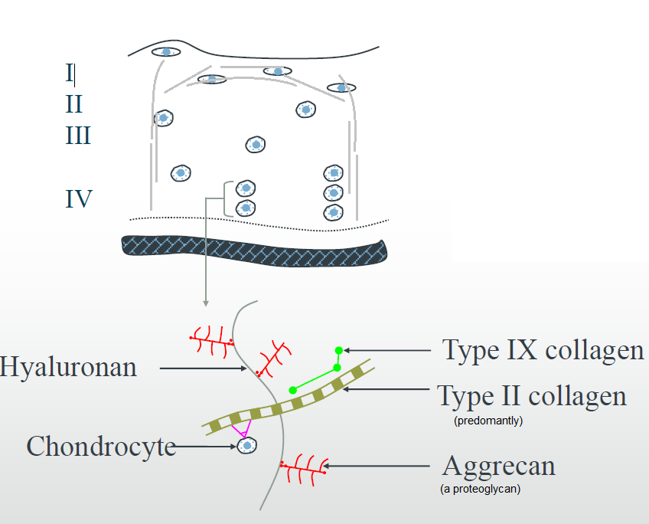

**Cartilage defects**

* Causes are sporting, work-related injuries and road traffic accidents
* A lot of people get cartilage problems at an older ager because of cartilage damage.
* 2 types of cartilage defect:

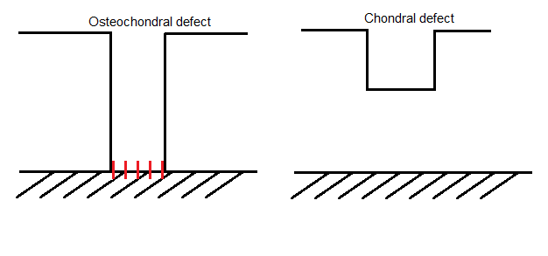

* Mechanical loading:  
  Cartilage is loaded cyclically (106 cycles per year), moreover the loading level can be quite significant (it can be 20% of the stress level).
* Therapy:
  + Pharmacology 🡪 “all drugs that work will have side effects”
  + Microfractures🡪 drill down into subchondral bone and release cells (only repair with growth factors)
  + Tissue graft
  + Use fibrocartilage as repair tissue
  + Cell transplantation  
    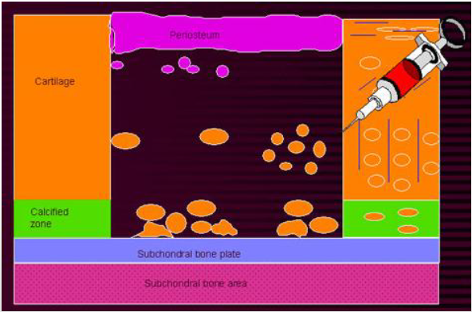  
    🡪 You inject back some autologous cells, you sow on a patch (biomaterials or periosteum (they were hoping that some stem cells of the periosteum helped the healing)).   
    🡪 In 2D culture chondrocyte dedifferentiate into fibrochondrocytes 🡪 you can see the change from ECM (chondrocyte produce collagen type 2 and fibrochondrocytes collegen type 1).   
    🡪 Chondrocytes have a strain history, so less loaded chondrocytes differ from more loaded ones.  
    🡪 Although there is a patch, they still lose some cells.  
    🡪 Success is questionable, since it will only help for 10 years.

Tissue Engineering

* Mechanical loading   
  Extracellular events: pH and osmatic pressure change (swelling), hydrostatic pressure, **cell deformation**, fluid flow, electrical streaming potentials (ions)  
  Intracellular events: nucleus distortion, mechano ion channels, integrins, mitochondria distortion, cytoskeletal reorganisation, nitric oxide, Ca2+ signalling (downstream mechanical responses), nucleotide release.  
  🡪 Agarose gels
  + Isolated chondrocytes are put in the agarose  
    🡪 similar sugar composition as proteoglycans
  + More simple transfer function than normal cartilage 🡪 simplification model system 🡪 easier to see what is happening.  
    (too much squeezing 🡪 cell ruptures)
  + Phenotype is retained (when the ECM is digested the cell becomes round again.
  + Reproducible and well established system and enable examination of the effects of the cell deformation on signalling pathways.
  + Bovine cells:
    - Max. strain of 15% (representable level)
    - Cell proliferation of dynamic tests do up regulate (static down), is dominated by superficial cells (higher density of cells on top).
    - GAG production only regulates up at 1 Hz (static down), is dominated by deep cells (higher density of GAGs). Optimisation of 15% strain always on 1 Hz (humans, horses).

🡪 So we need both the layers!

🡪 Dynamic compression inhibits the synthesis of NO (NO= bad 🡪 reduction of cell proliferation and production of GAGs). Cells that produce interleukin-1β (stimulates inflammation), an inhibitor of NO reverses this effect.  
🡪 Everyone should load mechanically (also old people!).

* + Human chondrocytes need a growth factor (TGFβ) before they will be active and so no effect in the culture media.  
    🡪 Lots of interplay between mechanical loading and biochemical responses, integrin blocking will result in no responses to mechanical loading.
* Scaffold materials  
  Explants, agarose, fibrin, PEGDM, PLA/PCL  
  🡪 Most of the scaffold look okay, but the mechanical properties are not good (compressive stiffness modulus of cartilage 1-10MPa, agarose 100kPa).  
  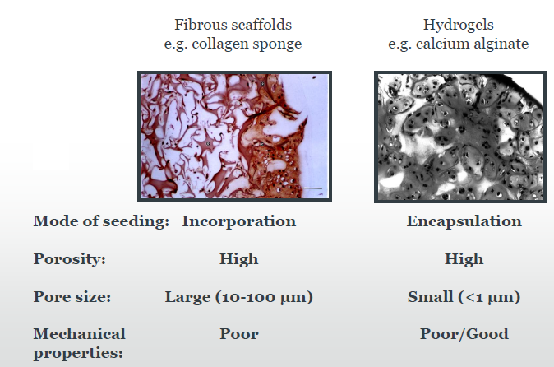
* Bioreactor  
  In Vitro (in a bioreactor 🡪 a controlled environment)  
  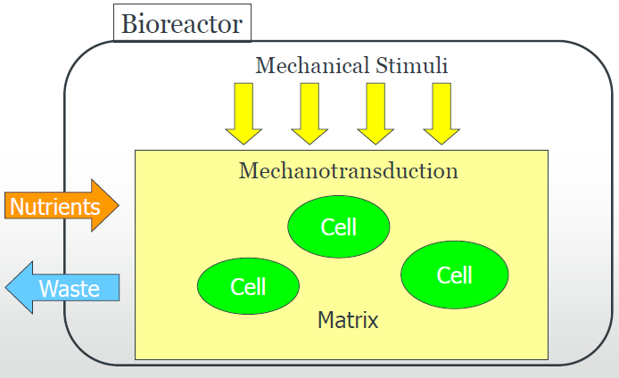  
  🡪 Role of the scaffold will become less important, sine cells makes their own matrix.   
  🡪 “Cells like being loaded”  
  🡪 Any device that provides the transport system for nutrients to cultured cells and allows the efficient withdrawal of toxic wastes and inhibitory metabolic by-products.
  + Applications  
    Developed for a range of biotechnology applications. For example, are routinely used for : microbial cell production of biologicals (e.g. penicillin), fermentation processes and waste management where there is close monitoring of culture conditions.
  + Features  
    Cell culture vessel(Rolling bottles, Rotating Wall Vessel, Airlift, Hollow fibre perfusion)  
    External Loop components(Peristaltic Pump, Manifold, Oxygenator, Medium and waste reservoir)  
    🡪 Oxygenation can be done by different methods:  
    1. Conventional methods of oxygenation disturb the medium and damage the cells.  
    2. Membrane oxygenation is adequate. Gas diffusion through a silicone membrane could be improved by decreasing the membrane thickness or more porous. (An example of this technology is the extra-corporeal oxygenators used in heart-lung machine)  
    Design Features(High productivity at reduced cost, High and consistent product quality, Simple validation ,Monitoring and control of pH, pO2 and pCO2, cells, infection and products Batch, fed batch and continuous e.g. chemostat, perfusion)
  + Considerations  
    Medium flowvia diffusion, osmosis and perfusion 🡪 produce shear stresses  
    Shear stress and turbulencecaused by friction between fluid particles, due to fluid viscosity Mass transfer is increased by agitating, (if this agitation is too much or if the cells are particularly shear sensitive, a reduction in net growth is observed, due to damage from fluid-mechanical forces)  
    Hydrodynamic Forces- moderate forces are required to maintain cells in suspension and provide adequate mass transport for nutrients and waste products. Techniques has been developed to shield cells.
  + Culture systems:
    - * Static cell cultures e.g. petri dishes, flat culture flasks
      * Static matrix cultures e.g. 3D constructs
      * Roller bottles 🡪 on a plate the roller bottle will go slower.
      * Airlift Bioreactors e.g. microcarriers beads on air bubbles
      * Stirred suspension carriers e.g. magnetic stirrers
      * Hollowed perfused fibre systems e.g. Vortex
      * Microgravity based bioreactors e.g. HARV, RWV
      * Others e.g. Spinner flasks yield turbulent mixing
  + Microgravity:  
    If cells remain buoyant in medium, these forces could be greatly reduced. This can be achieved by culturing cells in microgravity. To simulate microgravity, a cylindrical cultivation chamber completely filled with medium rotates horizontally, so that the net sum of all gravitational forces are zero - a state of continuous “free-fall”. Medium and chamber wall rotate as a solid body at the same angular velocity, eliminating shear forces at the interface.  
    🡪 Cells grow suspended and evenly dispersed in the chamber.   
    🡪 Better to get access to the nutrients and to get rid of the waste.  
    🡪 Aspect ratio is important design feature.
  + When something went wrong during the experiments in the past they remove the device and then examined the sample. Nowadays this can be done during the experiments with optical devices.
* Cell-polymer-bioreactor system:  
  The results for freshly harvested bovine chondrocytes, put in a bioreactor cultivation, implanted in a knee joint, followed for 40 days:  
  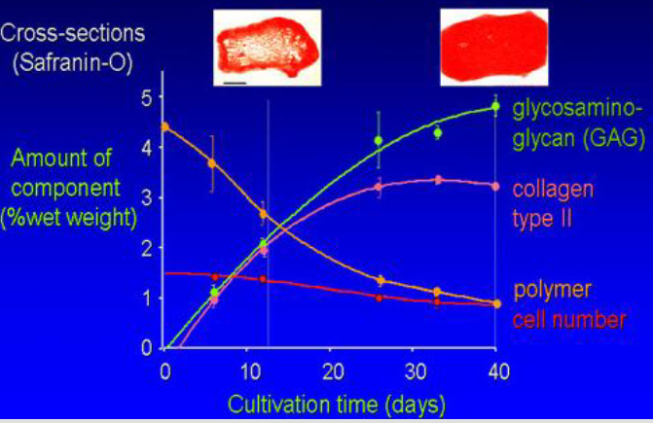  
  “Nearest data that replicate the graph of college 1 (29 November)”. The turnover of collagen takes more time. May be shear force needed for collagen?  
  🡪 The right mix of growth factors will reduce the doubling time, so breading cells will take less time.

Patients will have to be screened since the designed tissues will not be universally applicable. It will not be effective for all genotypes.